A COMMUNITY SERVICE PROJECT REPORT ON

ACADEMIC PERFORMANCE IMPROVEMENT SURVEY

Submitted in partial fulfilment for the award of the degree of

# BACHELOROFTECHNOLOGY

IN

Computer Science and Engineering

By

SATTI BHANU PRAKASH REDDY

22A81A05J0

Under the Esteemed Supervision of

MRS. D S L Manikanteswari

Assistant Professor



Department of **computer science and Engineering** (Accredited by **N.B.A**)

**SRI VASAVI ENGINEERING COLLEGE**(Autonomous)

(Affiliated to JNTUK, Kakinada) Pedatadepalli, Tadepalligudem-534101, AP

**2023-24**

**SRI VASAVI ENGINEERING COLLEGE**

**(Autonomous)**

**Department of Computer Science and Engineering**

**Pedatadepalli, Tadepalligudem**





This is to certify that the Community Service Project Report entitled “CYBER CRIME AWARNESS IN VILLAGES” survey done in Vallurupalle ,pentapadu village, submitted by Satti Bhanu Prakash Reddy (22a81a05j0), for the award of the degree of Bachelor of Technology in the Department of Computer Science and Engineering during the academic year 2023-2024.

|  |  |
| --- | --- |
| Name of Project Guide | Head of the Department |
| Mrs. D S L Manikanteswari | Dr. D Jaya Kumari |
| Assistant professor | Professor&HOD |

## **ACKNOWLEDGEMENT**

First and foremost, we sincerely salute to our esteemed institute **SRI VASAVI ENGINEERING COLLEGE**, for giving us this golden opportunity to fulfil our warm dream to become an engineer. Our sincere gratitude to our project guide **Mrs. D S L Manikanteswari** Assistant Professor, Department of Computer Science and Engineering, for his timely cooperation and valuable suggestions while carrying out this project.

We express our sincere thanks and heart full gratitude **to Dr. D. Jaya Kumari, M.Tech**, **Phd, Professor & Head of the Department of Computer Science and Engineering**, for permitting us to do our project. We express our sincere thanks and heart full gratitude to **Dr.** **G.V.N.S.R. Ratnakara Rao, Principal**, for providing a favourable environment and supporting us during the development of this project.

Our special thanks to the management and all the **teaching and non-teaching staff** **members, Department of Computer Science and Engineering**, for their support and cooperation in various ways during our project work. It is our pleasure to acknowledge the help of all those respected individuals.

We would like to express our gratitude to our parents, friends who helped to complete this project.

SATTI BHANU PRAKASH REDDY

22A81A05J0

**SRI VASAVI ENGINEERING COLLEGE**

**(Autonomous)**

**Department of Computer Science and Engineering**

**Pedatadepalli, Tadepalligudem**

**(2022-2023)**

**CSP- PROJECT**

**CYBER CRIME AWARNESS IN VILLAGES**

### **Academic Performance Improvement**

Name of the Student : SATTI BHANU PRAKASH REDDY

|  |  |
| --- | --- |
| Roll No | : 22A81A05J0 |
| Branch | : CSE |
| Semester | : Ⅲ |
| Topic | : CYBER CRIME AWARNESS IN VILLAGES |
| Area | :Vallurupalle,Pentapadu,Pedatadepalli |
| Project Guide | : Mrs. D S L Manikanteswari Asst.Professor |

**(STUDENT) PROJECT GUIDE**

**Mrs. D S L Manikanteswari**

(Asst.Professor)

**CONTENTS:**

* **INTRODUCTION**
* **CYBER CRIME AWARNESS IN VILLAGES**
* **AWARNESS PROGRAM & PHOTO GRAPHS OF SURVEY**
* **OBSERVATIONS**
* **SUGGECTIONS**
* **CONCLUSION**

**INTRODUCTION**

Cybercrime awareness in villages is the process of educating and empowering rural communities about the risks of cybercrime and how to protect themselves. It is important because cybercriminals often target rural areas because they are perceived as being more vulnerable.

There are a number of reasons why rural communities are more vulnerable to cybercrime. First, they may have less access to technology education and support. Second, they may be more trusting of people they know personally, which can make them more susceptible to social engineering scams. Third, they may be more reliant on digital services for essential services, such as banking and government benefits, which makes them more attractive targets for fraudsters.

The following are some of the most common types of cybercrime that affect villages:

* **Phishing:** Phishing scams are emails or text messages that attempt to trick people into revealing personal information, such as passwords or credit card numbers. Phishing scams are often targeted at rural communities because they are perceived as being more trusting.
* **Malware:** Malware is software that is designed to harm computers or networks. Malware can be spread through email attachments, malicious websites, or USB drives. Malware can steal personal information, damage computers, or disrupt networks.
* **Identity theft:** Identity theft is the act of stealing someone's personal information and using it to commit fraud. Identity thieves can use stolen information to open new accounts, apply for loans, or make purchases.
* **Financial fraud:** Financial fraud is any type of crime that involves stealing money or property. Financial fraud can include credit card fraud, wire fraud, and investment fraud.
* **Online scams:** Online scams are fraudulent schemes that are conducted over the internet. Online scams can include fake investment opportunities, pyramid schemes, and romance scams.

So our student’s took forward made awareness toword’s our villages about the cybercrime.

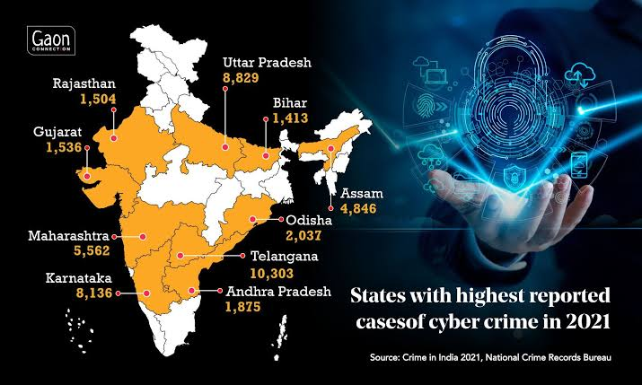

SO PLEASE BE AWARE AND BRING AWARNESS TOWORDS CYBER CRIME

**SURVEY PAPER’S**

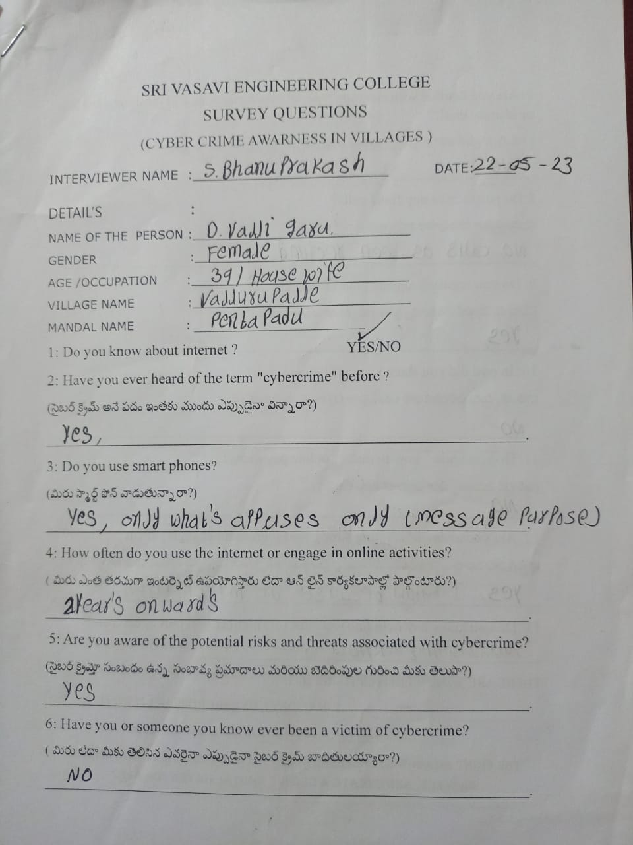

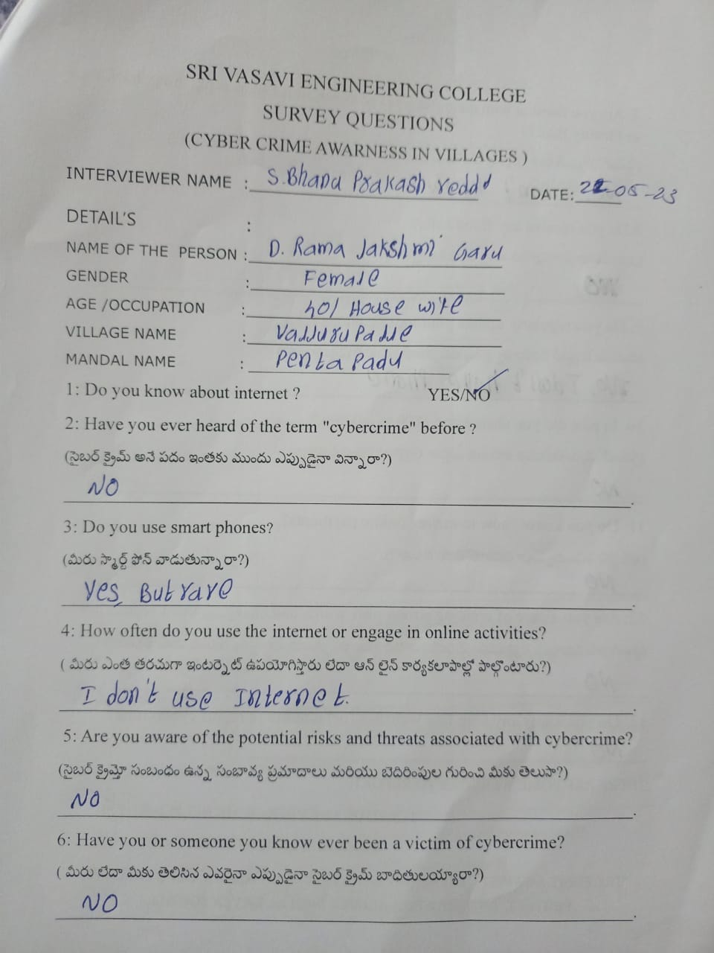

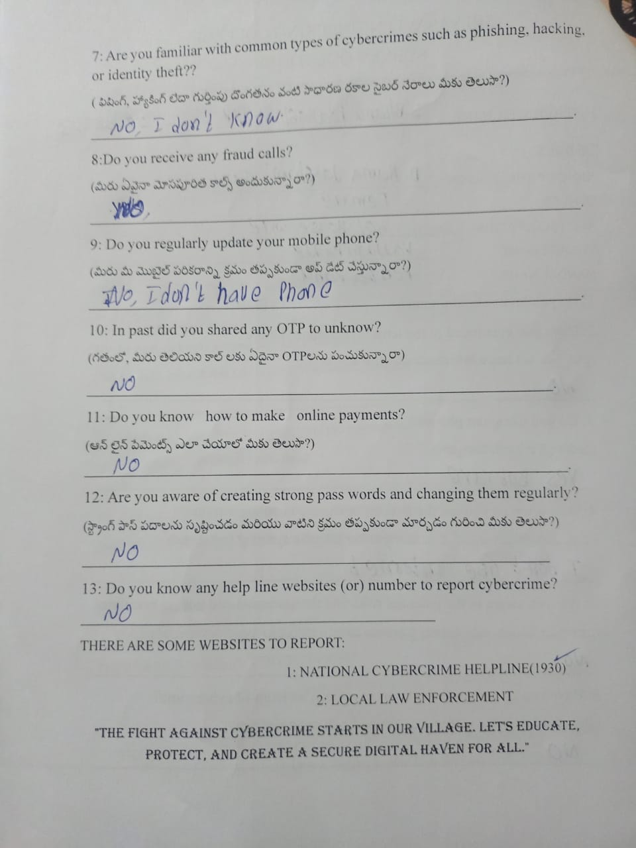

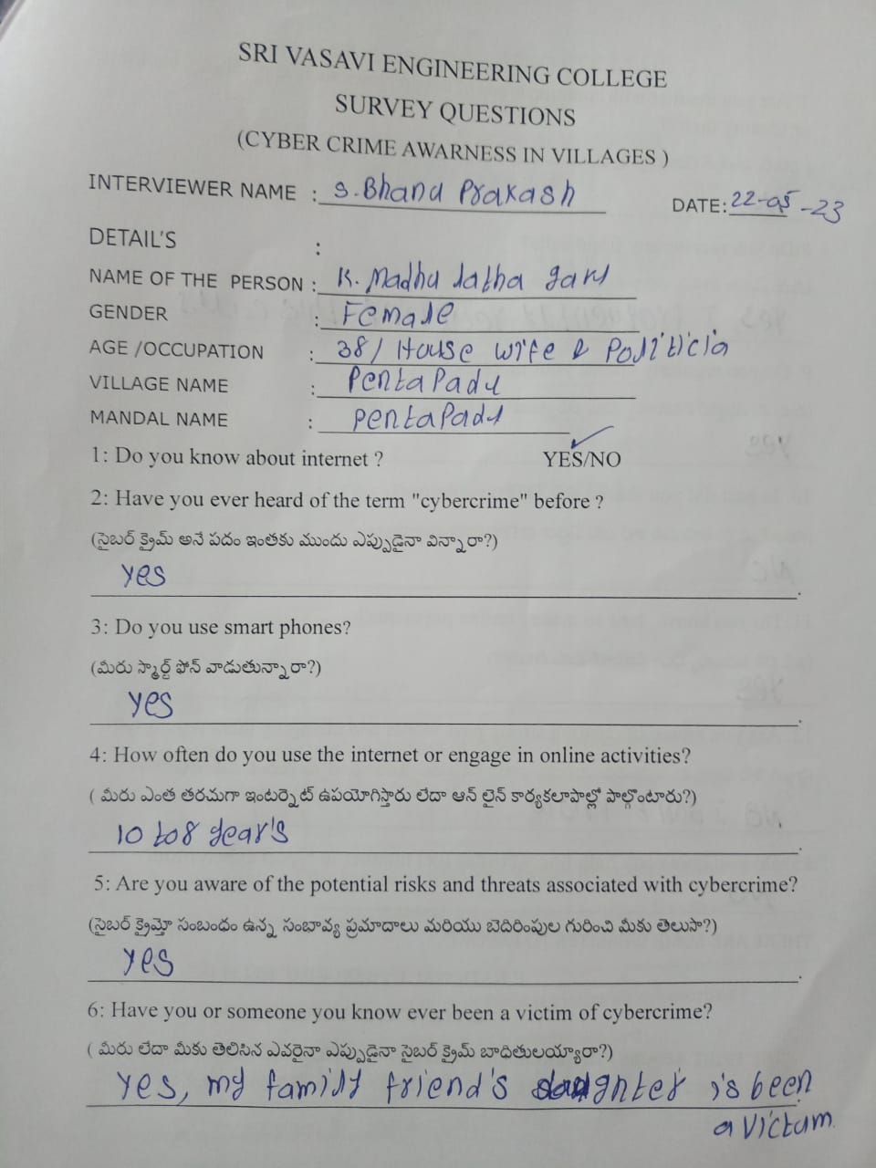



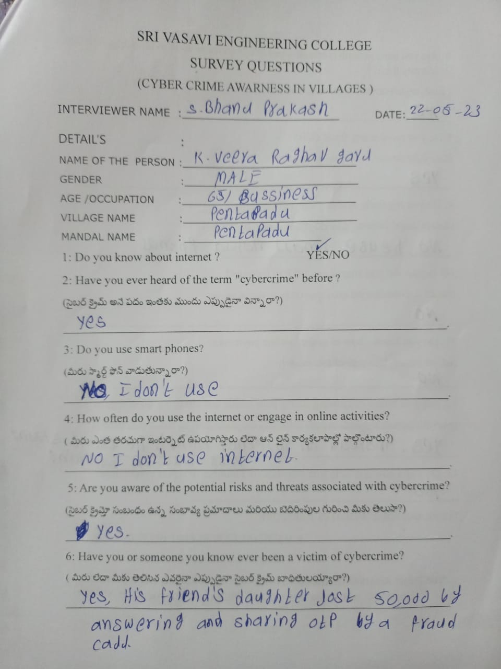

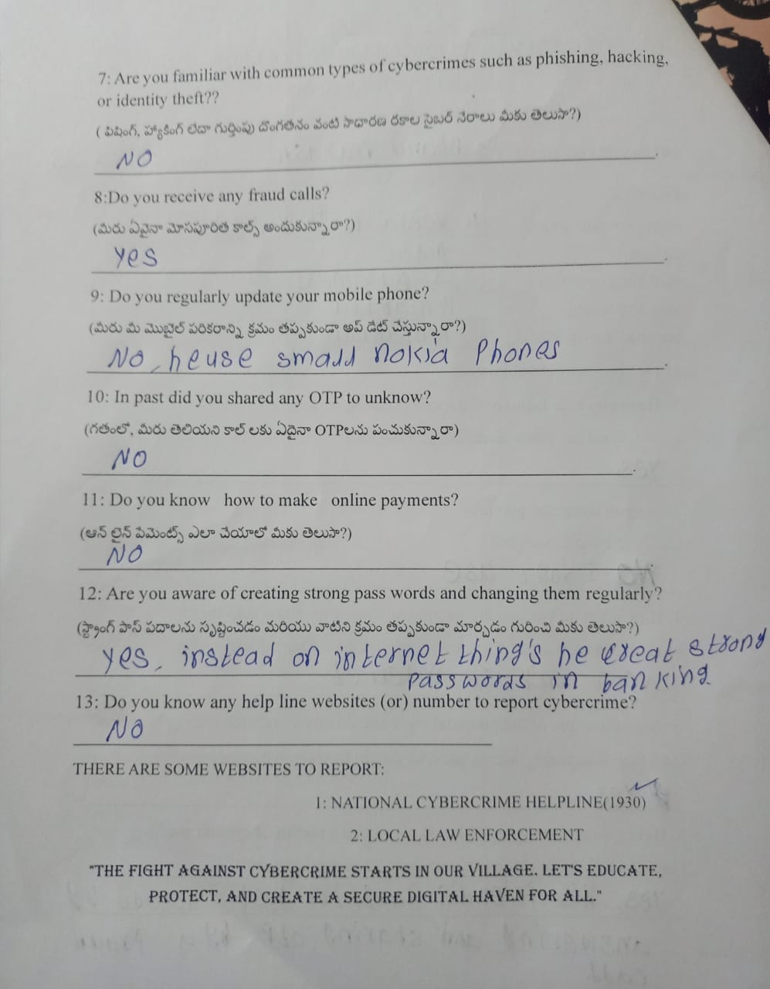

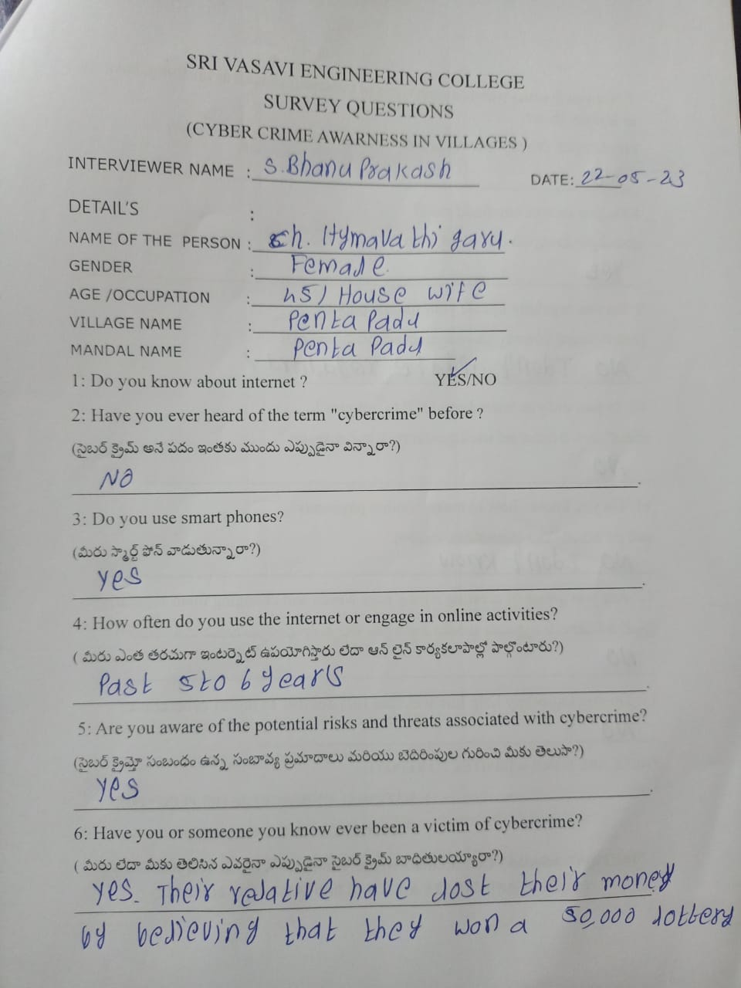

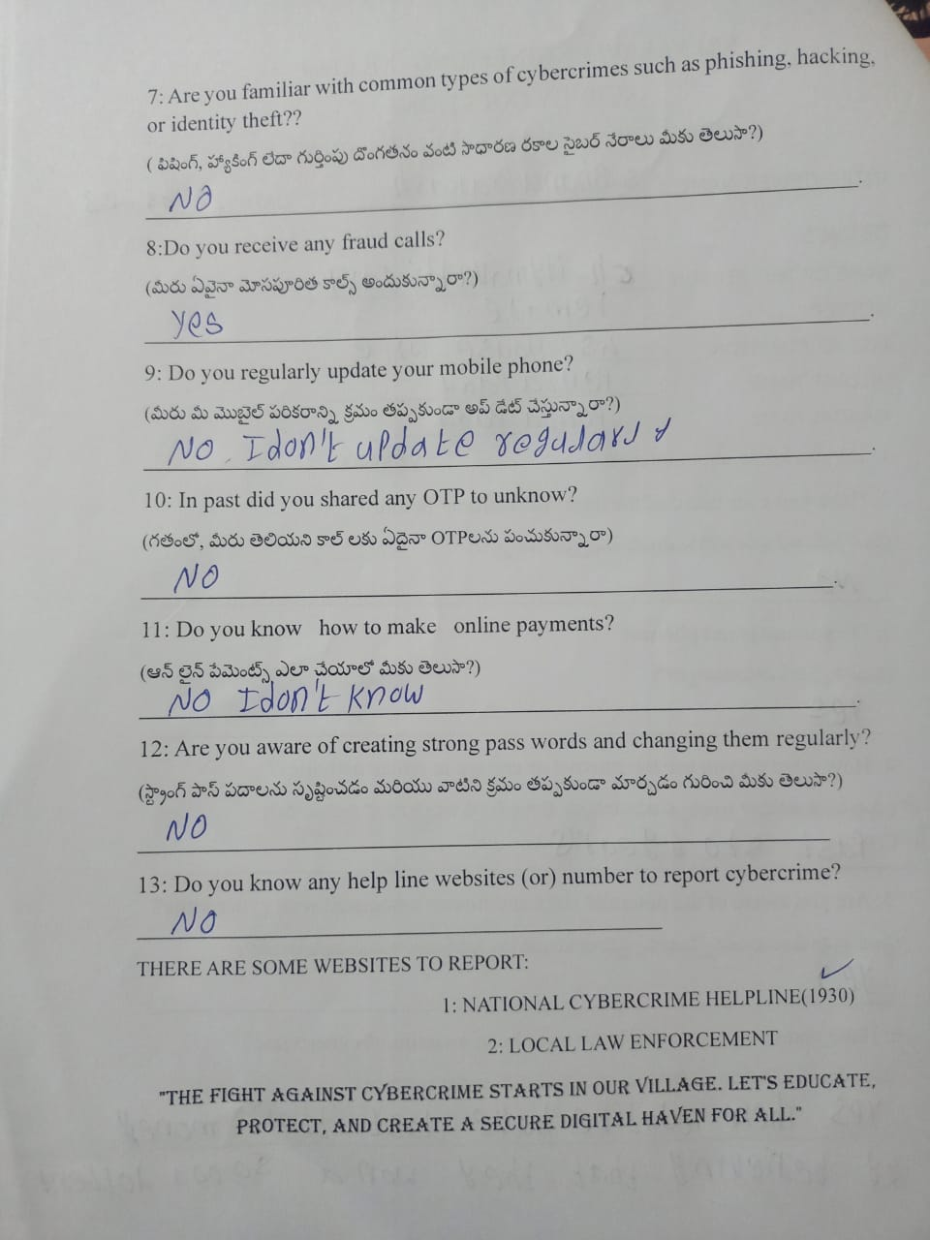

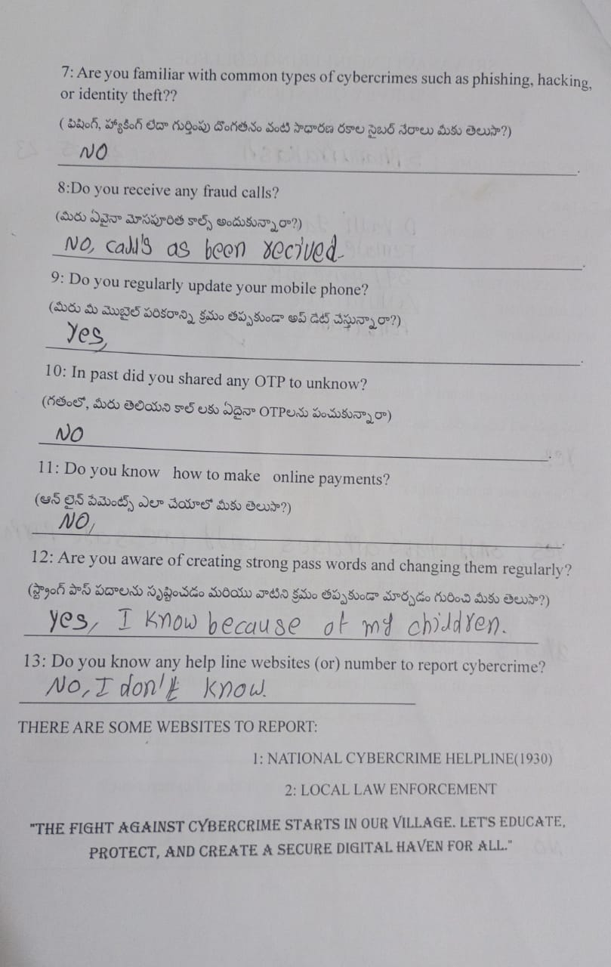

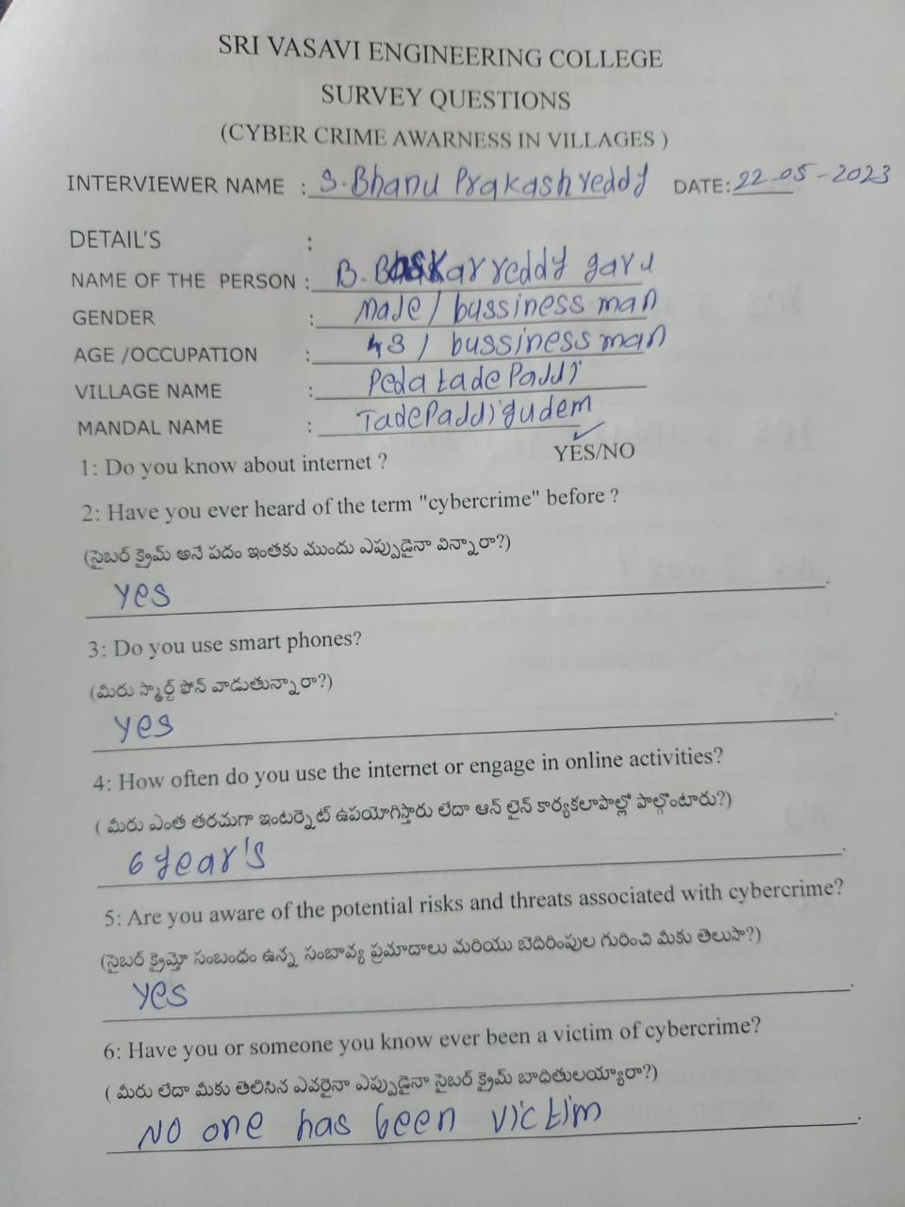 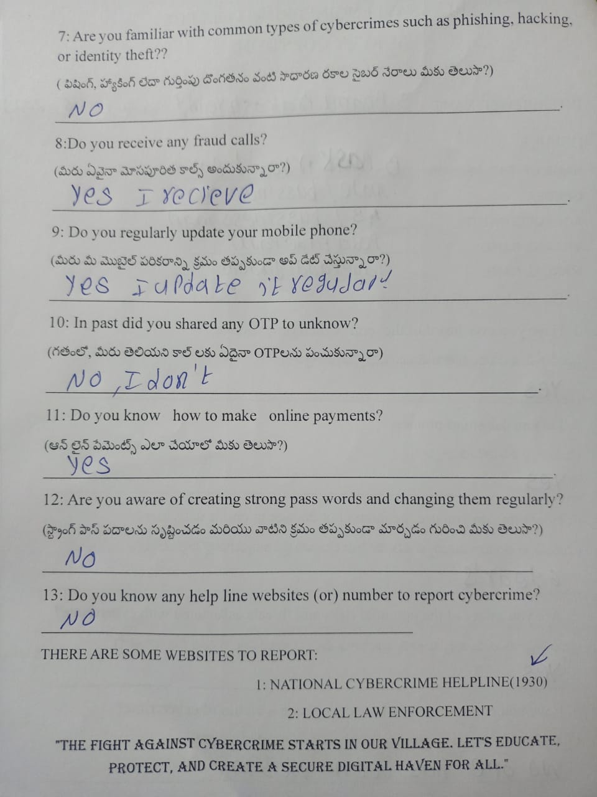

**PHOTOGRAPHS**

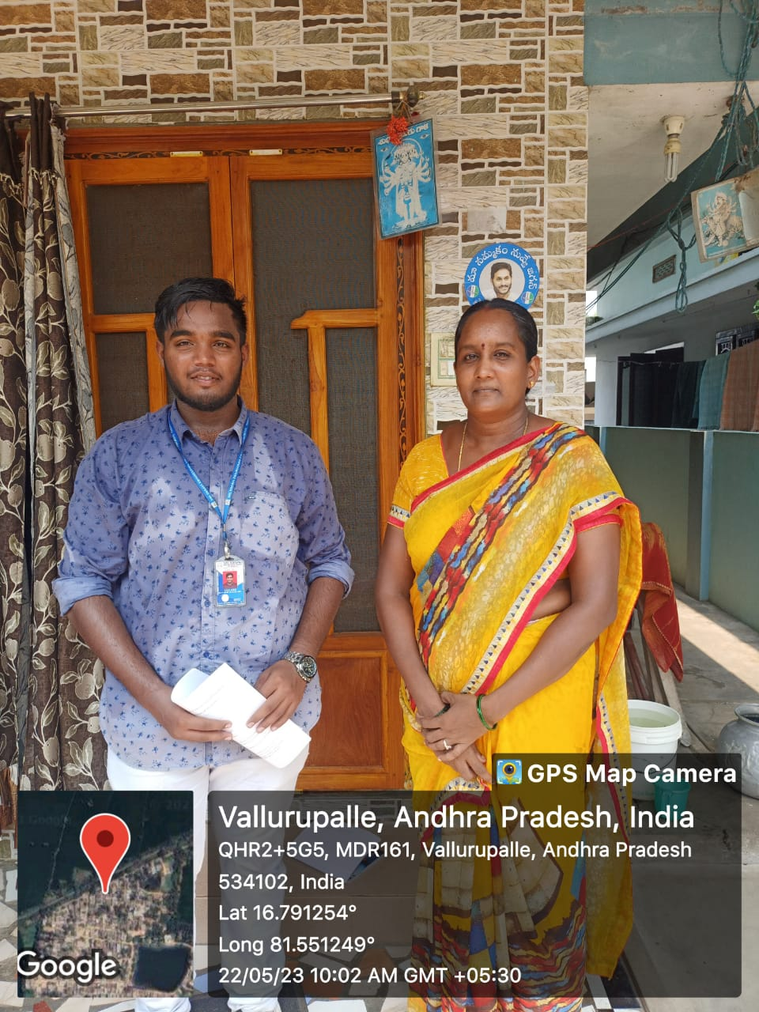

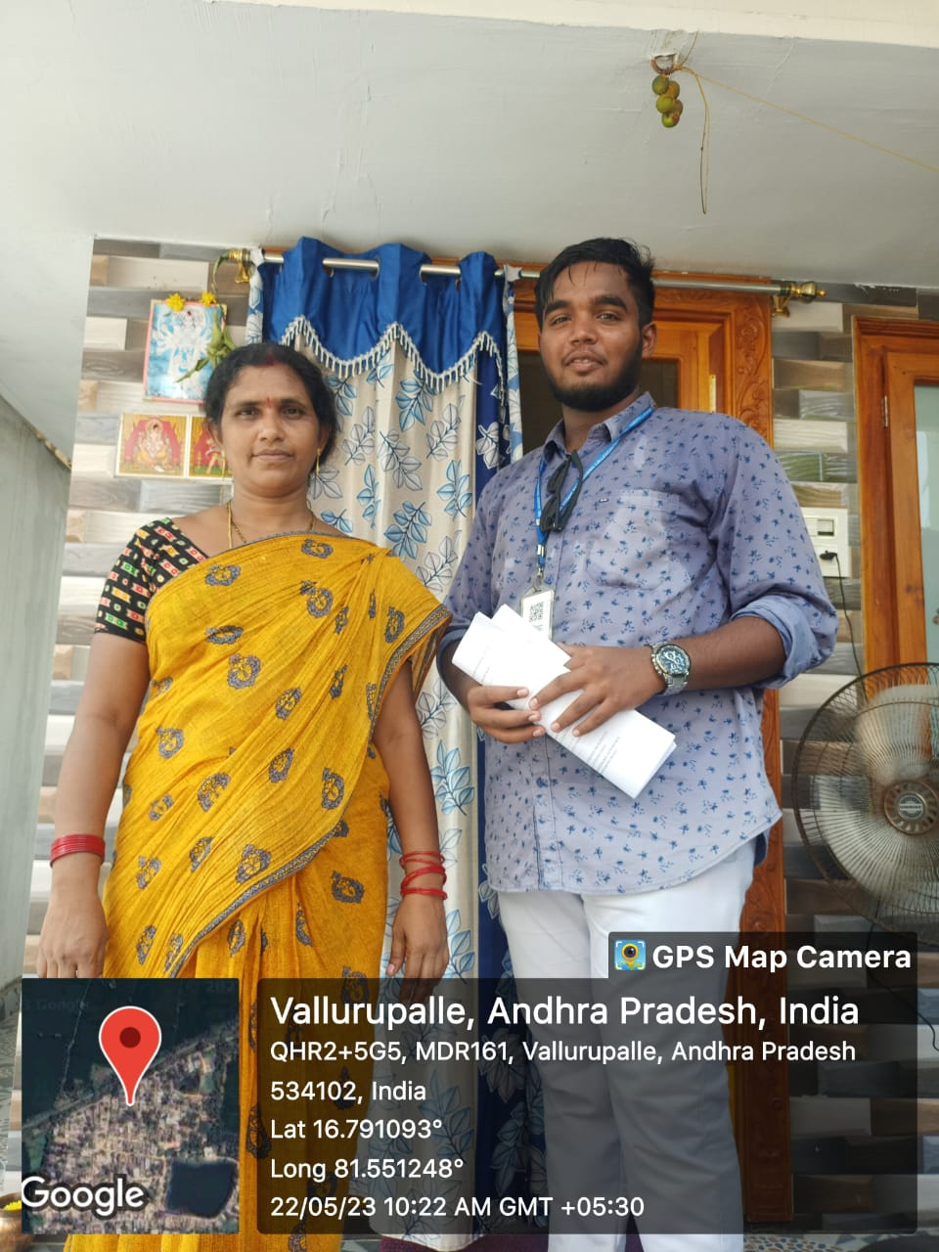 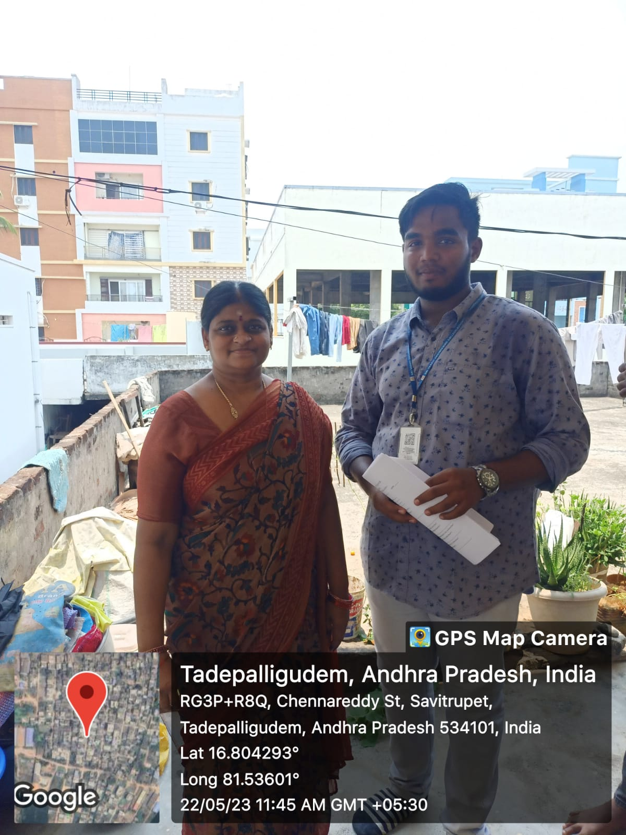

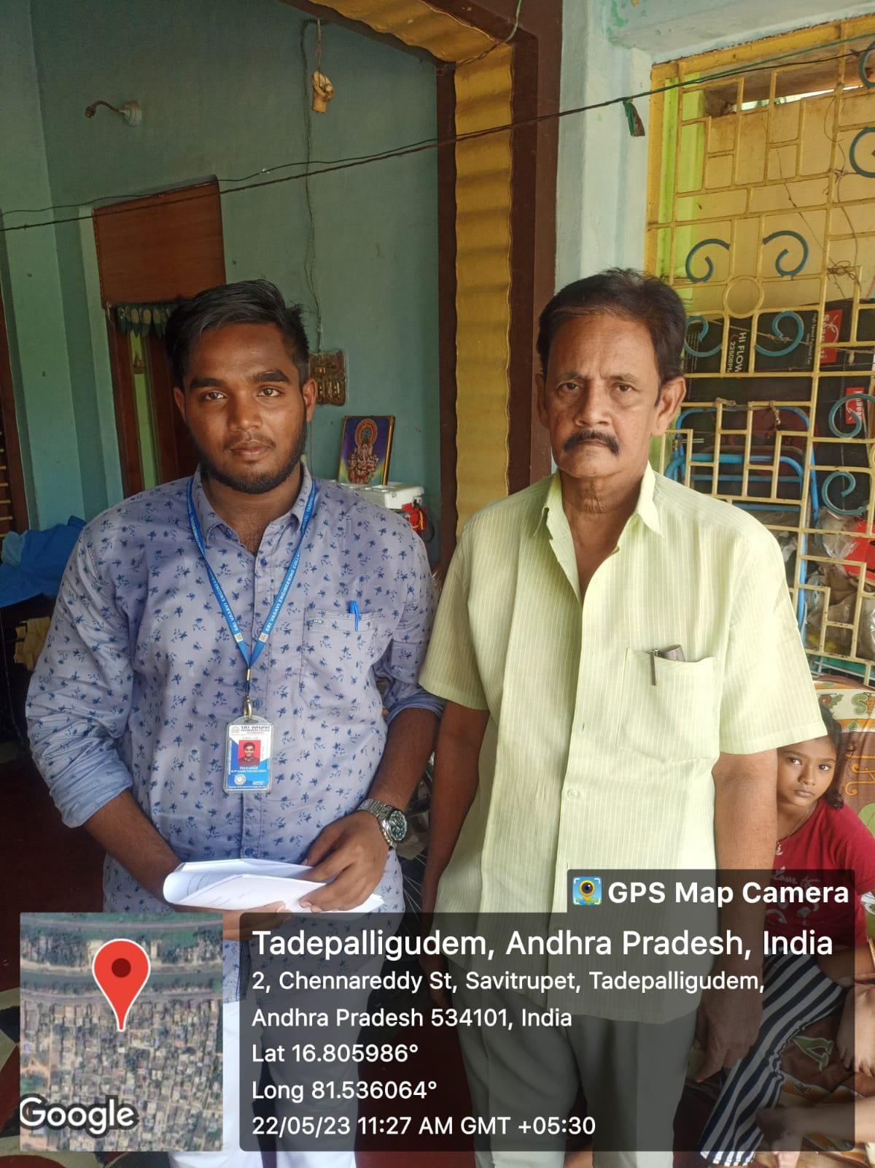

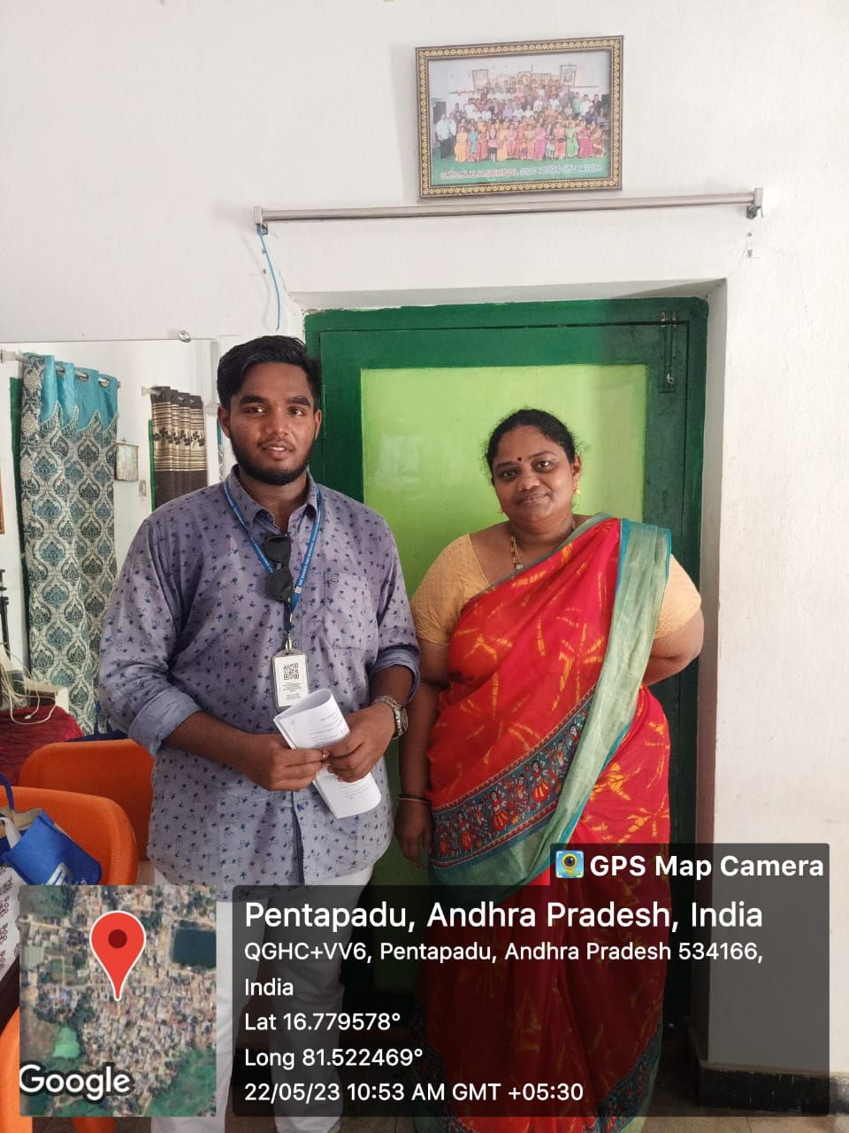

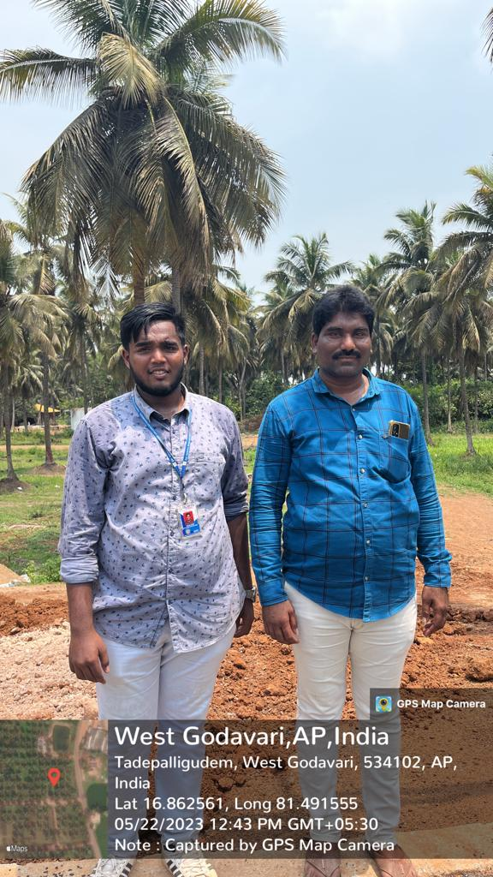

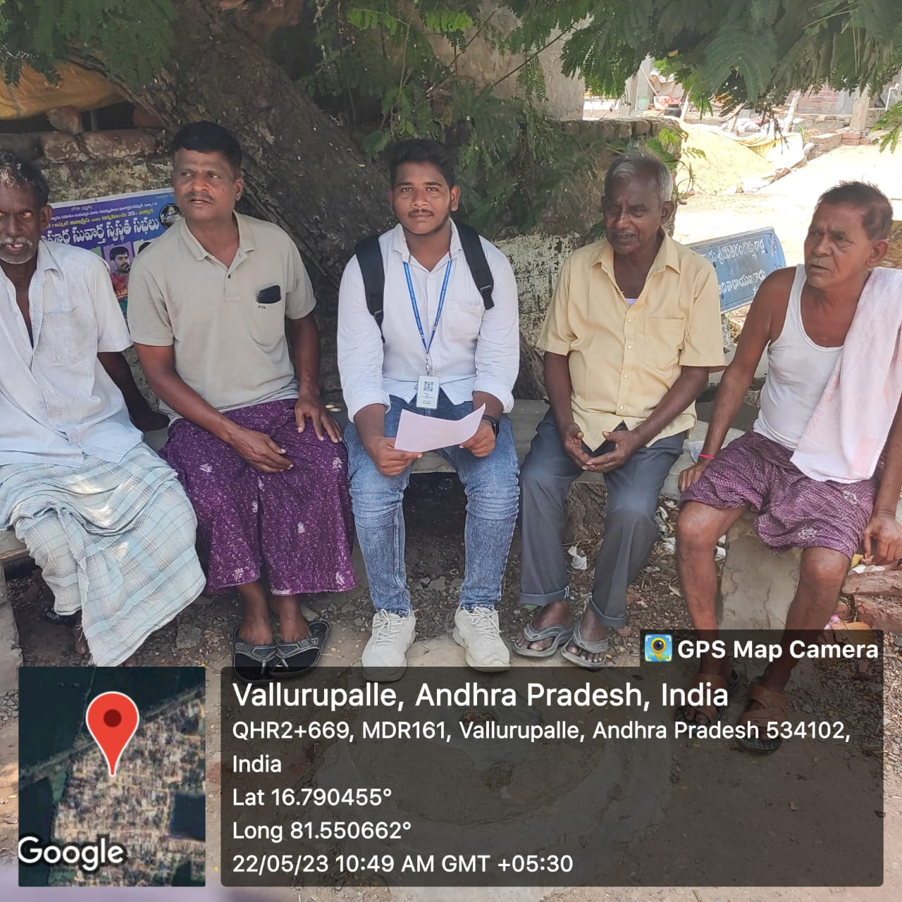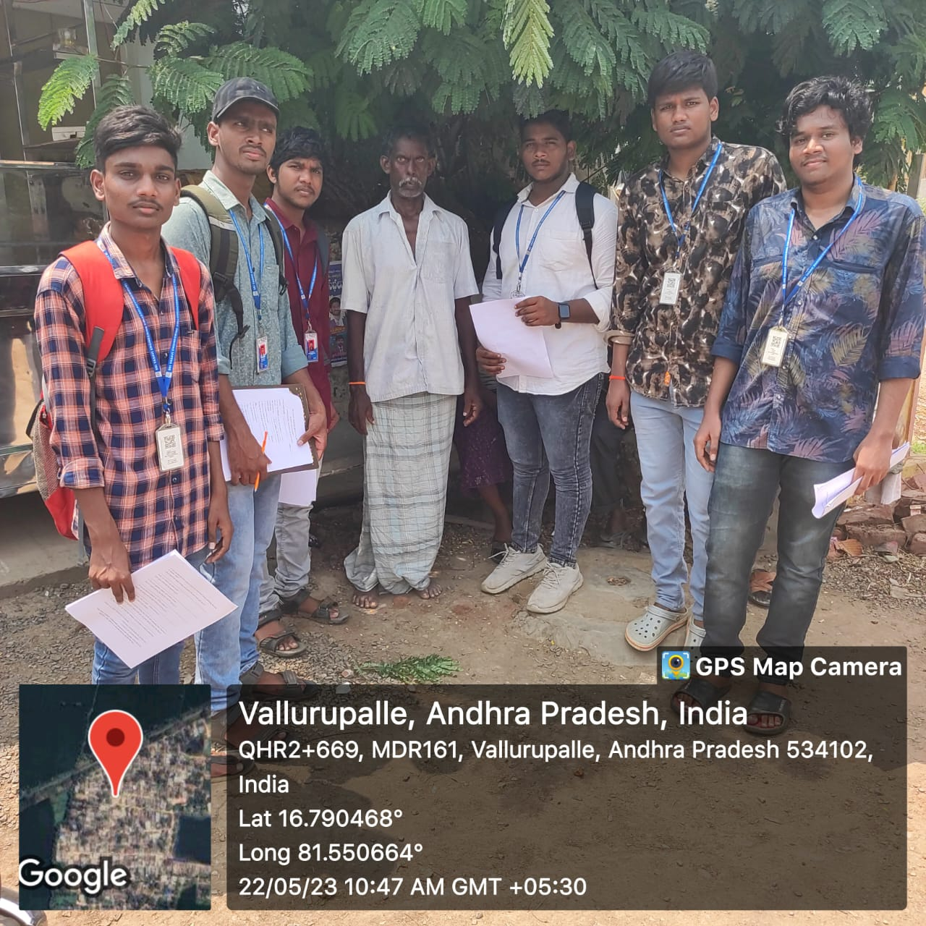

**OBSERVATION**

Here are some observations from conducting a cybercrime awareness in a village:

* **Lack of awareness:** Many people in the village were not aware of the different types of cybercrime or how to protect themselves. This was especially true for older people and people with less education.
* **Trust:** Many people in the village were trusting of people they knew personally, which made them more susceptible to social engineering scams.
* **Reluctance to report:** Some people were reluctant to report cybercrime incidents to the authorities, either because they didn't think it was serious or because they didn't know how to do it.

Mostly unluckily in villages so many were trapping in kind of hacking things like **phishing** and **randsomwere** mostly.

For Reporting this kind of activites we have some websites and phonenumber:

1: NATIONAL CYBERCRIME HELPLINE (1930)

2: LOCAL LAW INFORCEMENT

Overall, the cybercrime awareness in villages was a success. It helped to educate people about the risks of cybercrime and how to protect themselves. The camp also helped to build trust between the community and the authorities.

**CONCLUSION**

It is important for people in villages to be aware of the risks of cybercrime and to take steps to protect themselves. Some tips for protecting yourself from cybercrime include:

* Be careful about what information you share online. Only share personal information with websites and organizations that you trust.
* Use strong passwords and enable two-factor authentication whenever possible.
* Keep your software up to date. Software updates often include security patches that can help to protect your devices from malware.
* Be careful about opening emails and attachments from unknown senders.
* Report any suspicious activity to the authorities.
* **NATIONAL CYBER CRIME HELPLINE (1930)**

By following these tips, people in villages can help to protect themselves from cybercrime.

In addition to taking individual steps to protect themselves, people in villages can also work together to create a more secure community. This could involve organizing community workshops on cybercrime prevention, developing cybercrime awareness curriculum for local schools, or creating cybercrime awareness poster campaigns.

By working together, people in villages can make their communities more resilient to cybercrime.

CYBER CRIME AWARNESS IN VILLAGES

**SUGGECTIONS**

**These are some specific activities that you could do to raise cybercrime awareness in villages**

* Organize a community workshop on cybercrime prevention. Invite a speaker from a local police department or cyber security organization to talk about the risks of cybercrime and how to protect oneself.
* Develop a cybercrime awareness curriculum for local schools. Teach students about basic security practices, such as strong passwords and being careful about what information they share online.
* Create a cybercrime awareness poster campaign. Display posters in community centers, schools, and other public places.
* Develop a cybercrime awareness mobile app. This app could provide users with information about the latest cybercrime threats and how to protect themselves.
* Partner with local businesses and organizations to offer cybercrime awareness training. This could include training for employees, customers, and volunteers.

By taking these steps, you can help to raise awareness of cybercrime in villages and make people more resilient to attack.

BRING AWARNESS TO VILLAGES

**PROJECT LOGBOOK**

|  |  |
| --- | --- |
| **Student Name** | SATTI BHANU PRAKASH REDDY |
| **Reg.Number** | 22A81A05J0 |
| **Branch** | CSE |
| **Year** | 2023-2024 |
| **Title of the community service project** | CYBER CRIME AWARNESS IN VILLAGES |
| **Guide Name** | Mrs. D S L Manikanteswari |

|  |  |  |  |  |  |
| --- | --- | --- | --- | --- | --- |
| **S.No** | **DATE** | Guidance Given | Student Activities | Target Achived | Signature of Guide |
| 1 |  |  |  |  |  |
| 2 |  |  |  |  |  |
| 3 |  |  |  |  |  |
| 4 |  |  |  |  |  |
| 5 |  |  |  |  |  |
| 6 |  |  |  |  |  |

**Project Guide Project Coordinator Head of the Department**